

| **TITLE : To perform VLab on NLP** |
| --- |

**AIM:** Vlab on NLP

**Expected OUTCOME of Experiment:**

CO5: Apply data analytics in the field of Health care.

**_____________________________________________________________________**

**Books/ Journals/ Websites referred:**

* vlab
* google

**_____________________________________________________________________**

**Pre Lab/ Prior Concepts:**

Students should have a basic understanding of word analysis.

**Procedure:**

**Vlab Name: Computer Science and Engineering -Natural Language Processing- Word Generation**

**Vlab Link:** [**https://nlp-iiith.vlabs.ac.in/exp/morphology/**](https://nlp-iiith.vlabs.ac.in/exp/morphology/)

Implementation details:

The Objective of the experiment is understanding the morphology of a word by the use of Add-Delete table.

STEP 1: Select a word root.

STEP 2: Fill the add-delete table and submit.

STEP 3: If wrong, see the correct answer or repeat STEP1.

Output:

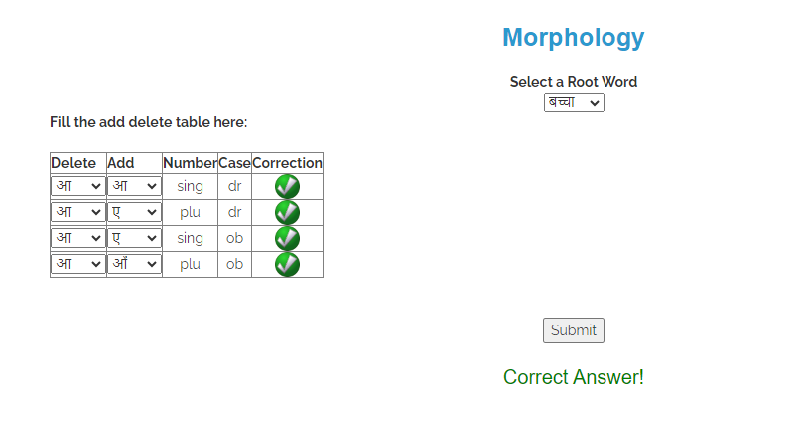

**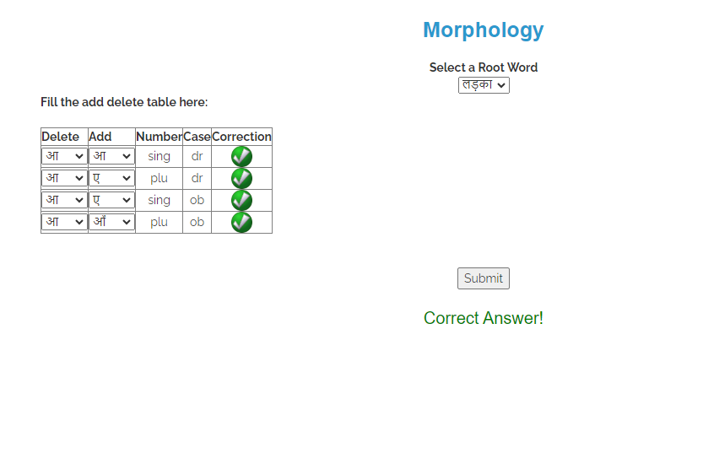  
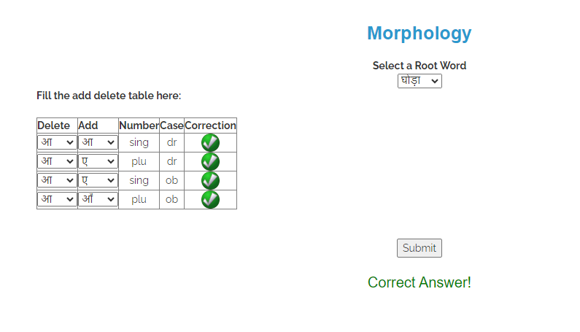  
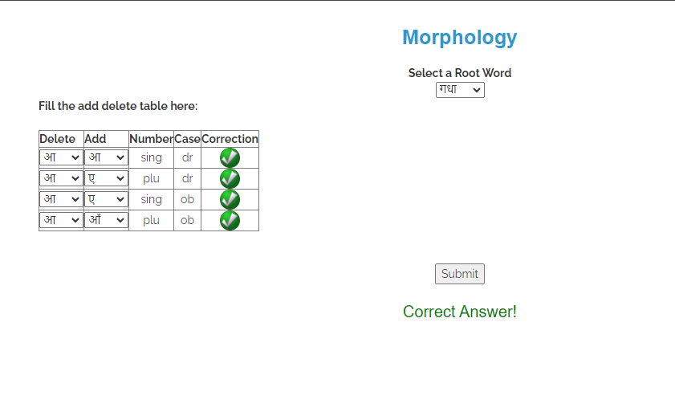  
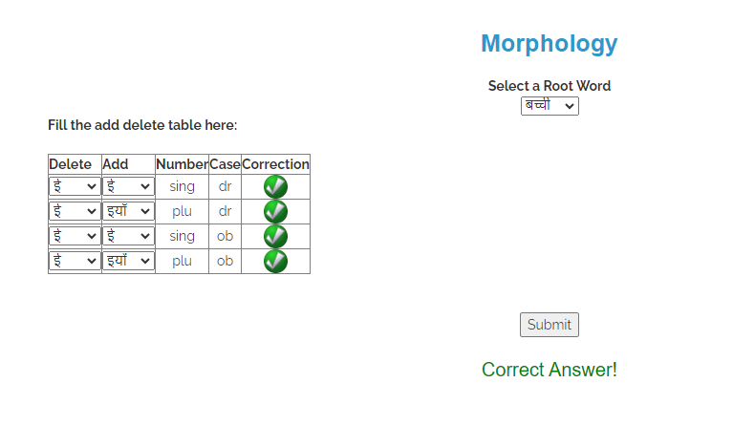  
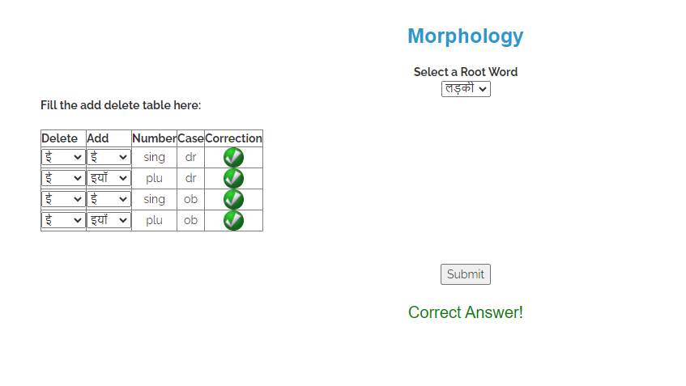  
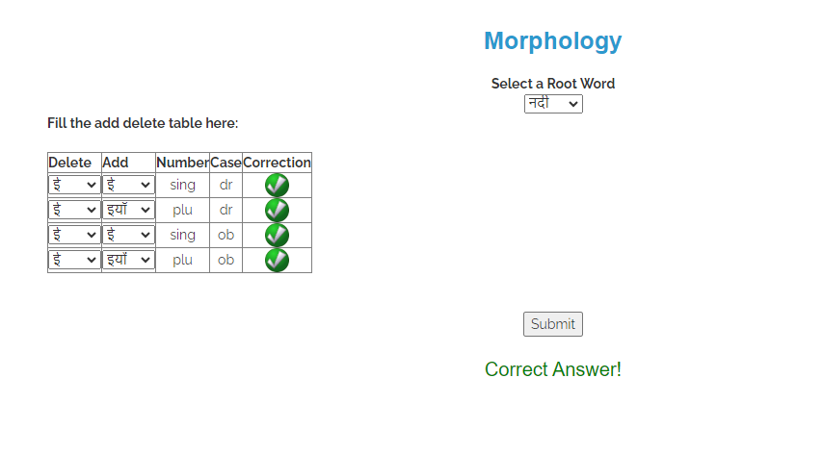**

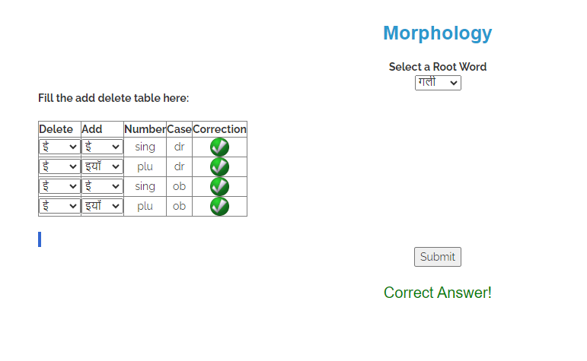

**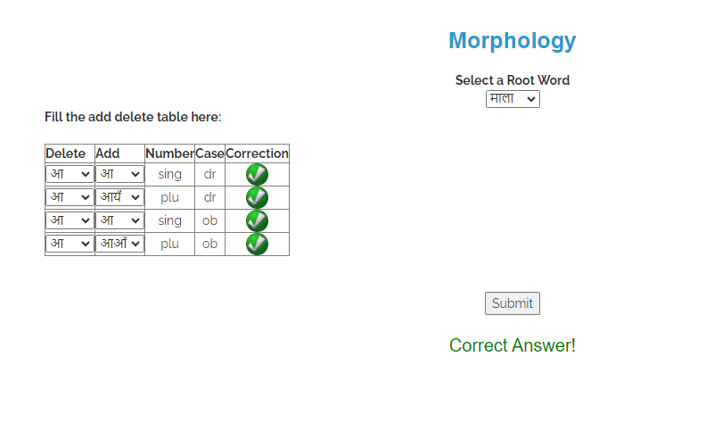  
  
  
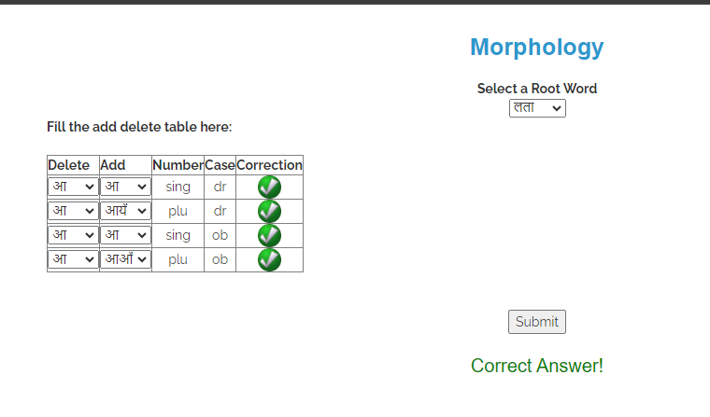**

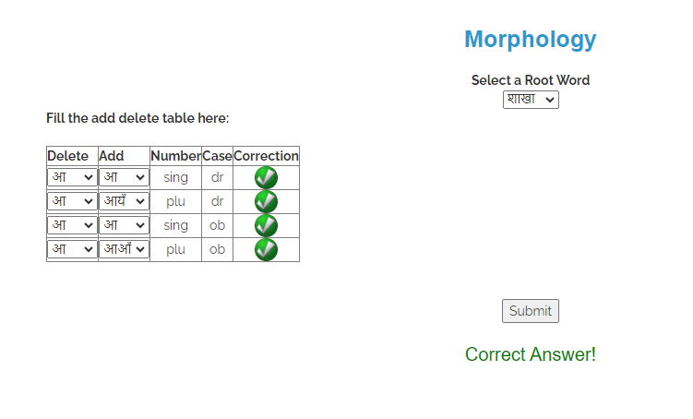

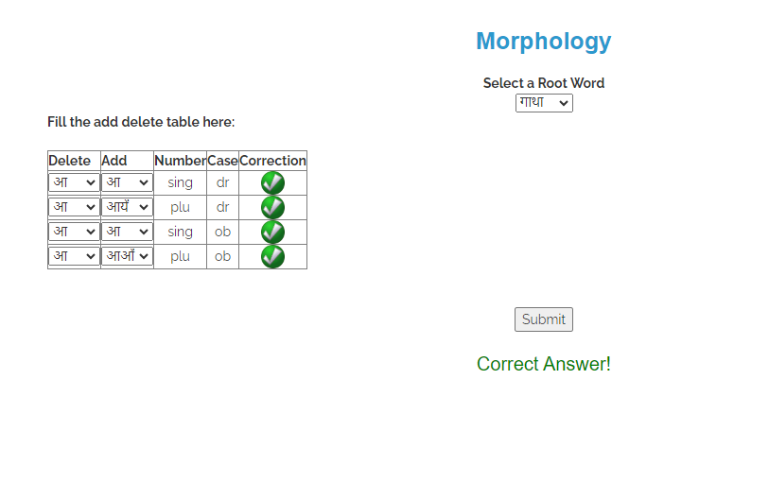

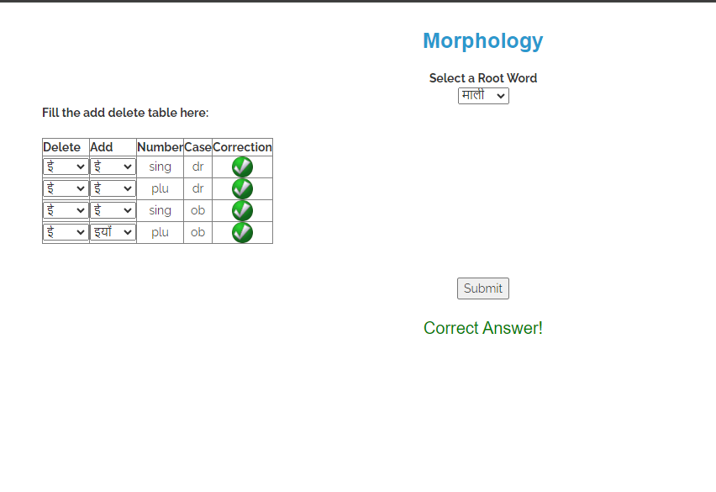

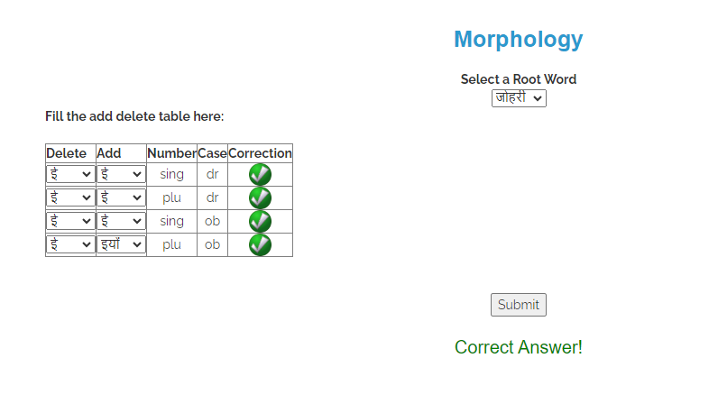

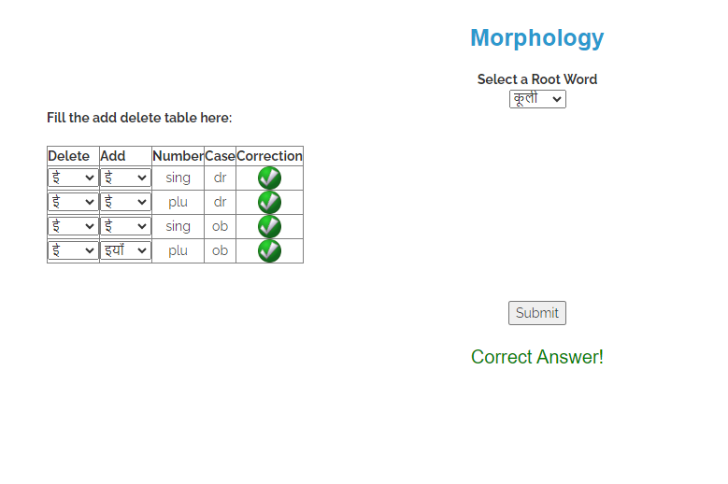

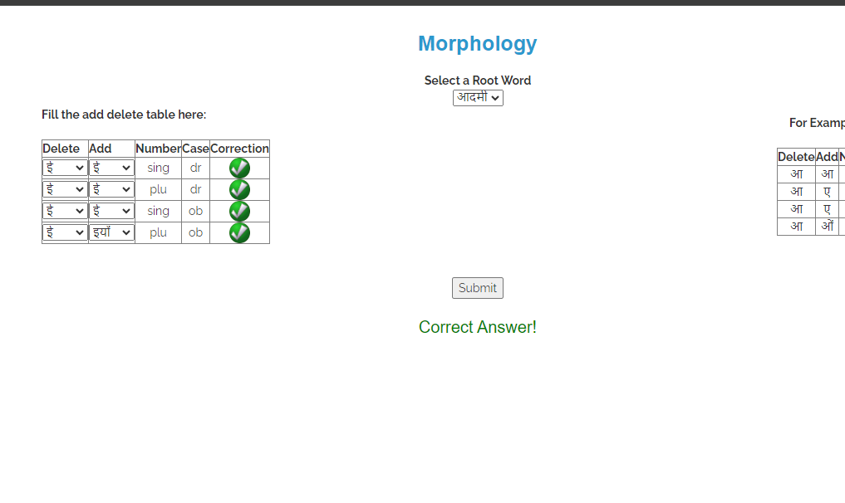

**Date: 17/10/2024 Signature of faculty in-charge**

**Post Lab Descriptive Questions:**

Q.1 Explain various applications of NLP.

* **Content Recommendation**: Analyzes user preferences for tailored suggestions
* **Sentiment Analysis**: Gauges public opinion from social media and reviews.
* **Chatbots/Assistants**: Powers tools like Siri and Alexa for user interaction.
* **Text Classification**: Categorizes texts for spam detection and organization.
* **Healthcare**: Extracts insights from medical records for better patient care.

Q.2 What is the significance of Natural Language Processing (NLP) in modern technology, and how does it impact various industries?

The significance of

* **Customer Service**: Automating responses to improve satisfaction.
* **Marketing**: Analyzing sentiment for targeted campaigns.
* **Finance**: Aiding risk assessment and fraud detection.
* **Education**: Personalizing learning experiences.
* **Healthcare**: Extracting insights from medical data for better care.
* **E-commerce**: Optimizing searches and recommendations to drive sales